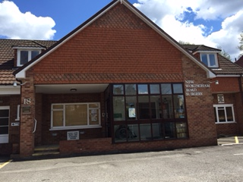

**New Wokingham Road Surgery**

**Crowthorne, Berkshire RG45 6JL**

* 9500 patients (long-term growth 4-5% annually)
* 2 Partners and 1 part time salaried GP
* ANP / Paramedic / Pharmacist / Physio / Phlebotomy etc

Our thriving Practice is ready to welcome a new Partner to our dedicated team.

We are a long established and hard-working Practice in a Partner owned Surgery.

We consistently perform very highly in the GP Patient Survey and patient satisfaction.

You would join an easy-going team of clinicians that provide a high level of patient care in a friendly and supportive environment, where special interests and new ways of working are encouraged.

We are hoping to rebalance our Partnership to allow for further growth, with a sustainable long-term work – life balance.

Applications from newly qualified and established GPs (Salaried or Partners) are welcome. We offer an income that reflects our high performing Practice.

Contact us for an informal chat, tell us about yourself and what you would like your GP career to look like… you may well be the person for us.

[davidevans5@nhs.net](mailto:davidevans5@nhs.net) (Partner) or our Practice Manager Jane Kirkwood [jane.kirkwood1@nhs.net](mailto:jane.kirkwood1@nhs.net)